Lab Exercise 4- Working with Docker Networking

Name: Aman sain

SAP ID: 500107367

Rollno.: R2142220418

Batch: DevSecOps B1

Step 1: Understanding Docker Default Networks

Docker provides three default networks:

- bridge: The default network when a container starts.

- host: Bypasses Docker’s network isolation and attaches the container directly to the host network.

- none: No networking is available for the container.

1.1. Inspect Default Networks

Check Docker's default networks using:

docker network ls

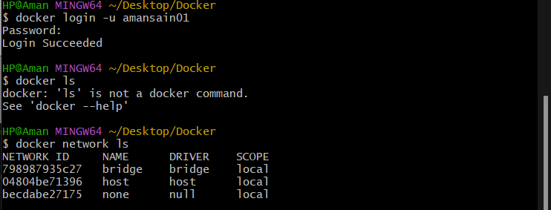

1.2. Inspect the Bridge Network

docker network inspect bridge
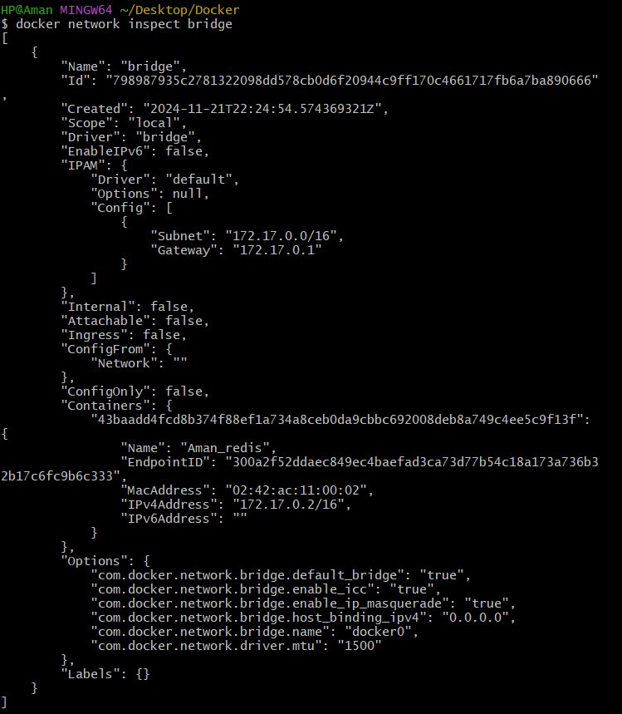

This command will show detailed information about the bridge network, including the connected containers and IP address ranges.

Step 2: Create and Use a Bridge Network

2.1. Create a User-Defined Bridge Network

A user-defined bridge network allows containers to communicate by name instead of IP.

docker network create my_bridge
2.2. Run Containers on the User-Defined Network

Start two containers on the newly created my_bridge network:

docker run -dit --name container1 --network my_bridge busybox
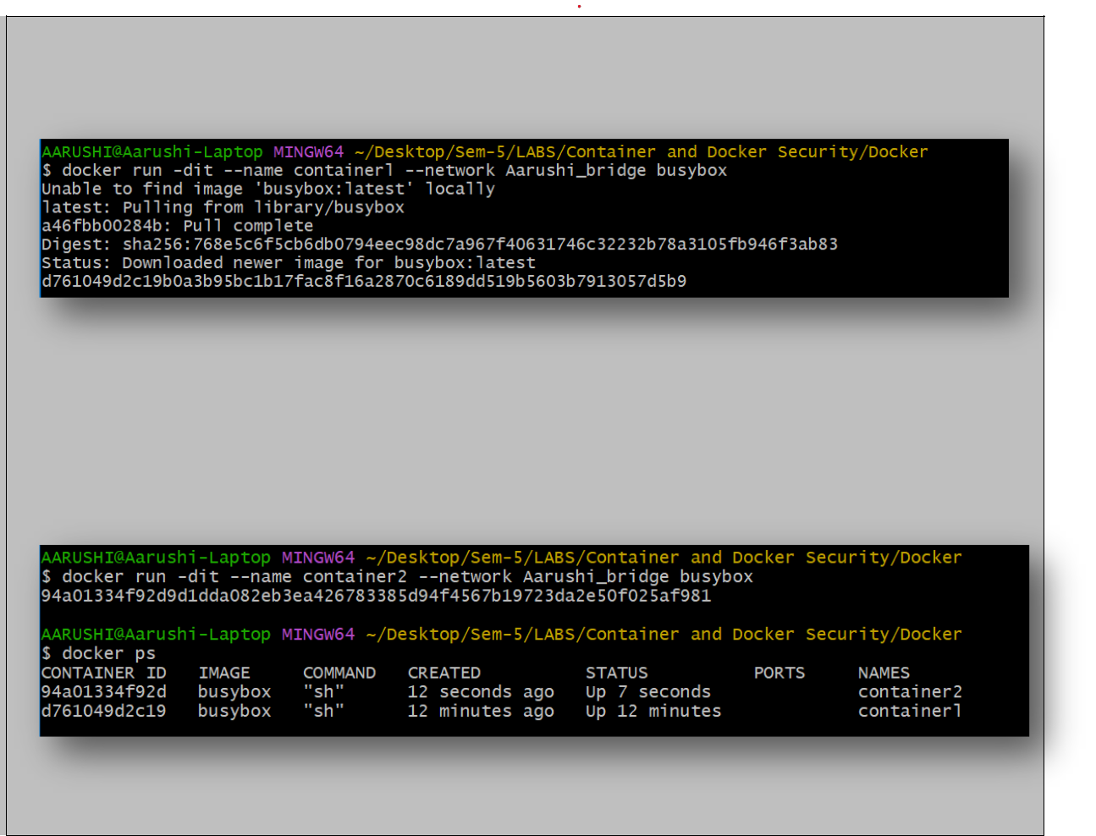

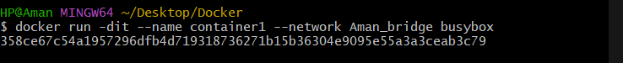

docker run -dit --name container2 --network my_bridge busybox
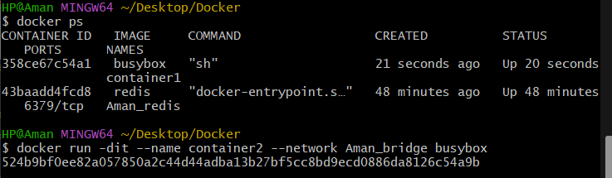

2.3. Test Container Communication

Execute a ping command from container1 to container2 using container names:
docker exec -it container1 ping container2
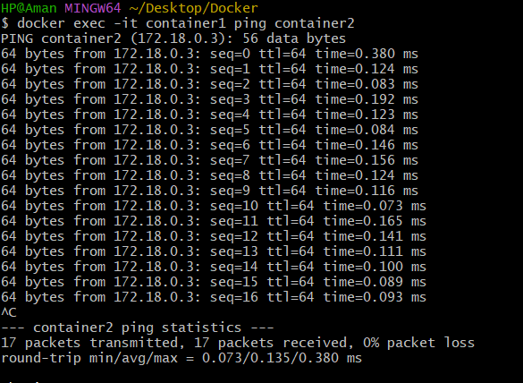
The containers should be able to communicate since they are on the same network.

Step 3: Create and Use a Host Network

3.1. Run a Container Using the Host Network

The host network allows the container to use the host machine’s networking stack:

docker run -d --name host_network_container --network host nginx

Access the NGINX server via localhost:80 in your browser to verify the container is using the host network.

3.2. Check Network docker network inspect host

docker network inspect host

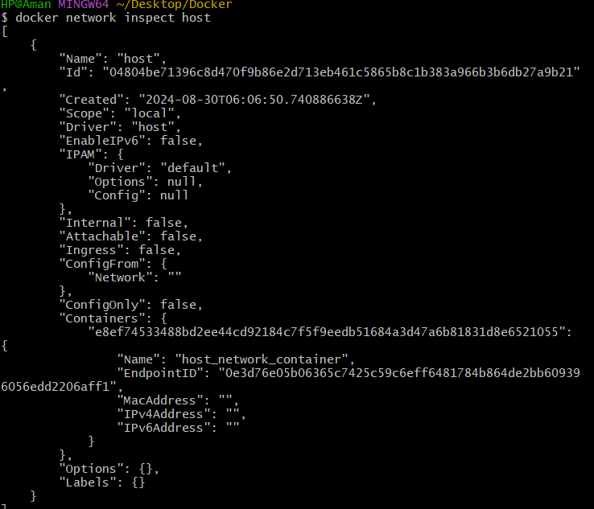
Step 4: Disconnect and Remove Networks

4.1. Disconnect Containers from Networks To disconnect container1 from my_bridge:

docker network disconnect my_bridge container1
4.2. Remove Networks

To remove the user-defined network:

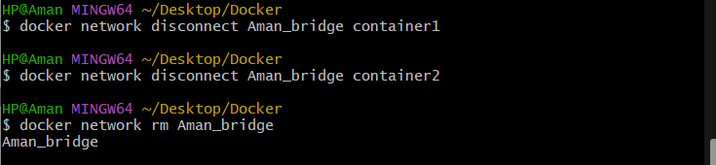
docker network rm my_bridge
Step 5: Clean Up

Stop and remove all containers created during this exercise:

docker rm -f container1 container2
